**Task 1: System Monitoring Setup**

**Objective**

Set up CPU, memory, and disk usage monitoring using CLI tools like htop, nmon, df, and du, and capture logs to help in system performance analysis.

**Step 1: Install Monitoring Tools ( *htop* )**  
 sudo apt update

sudo apt install -y htop

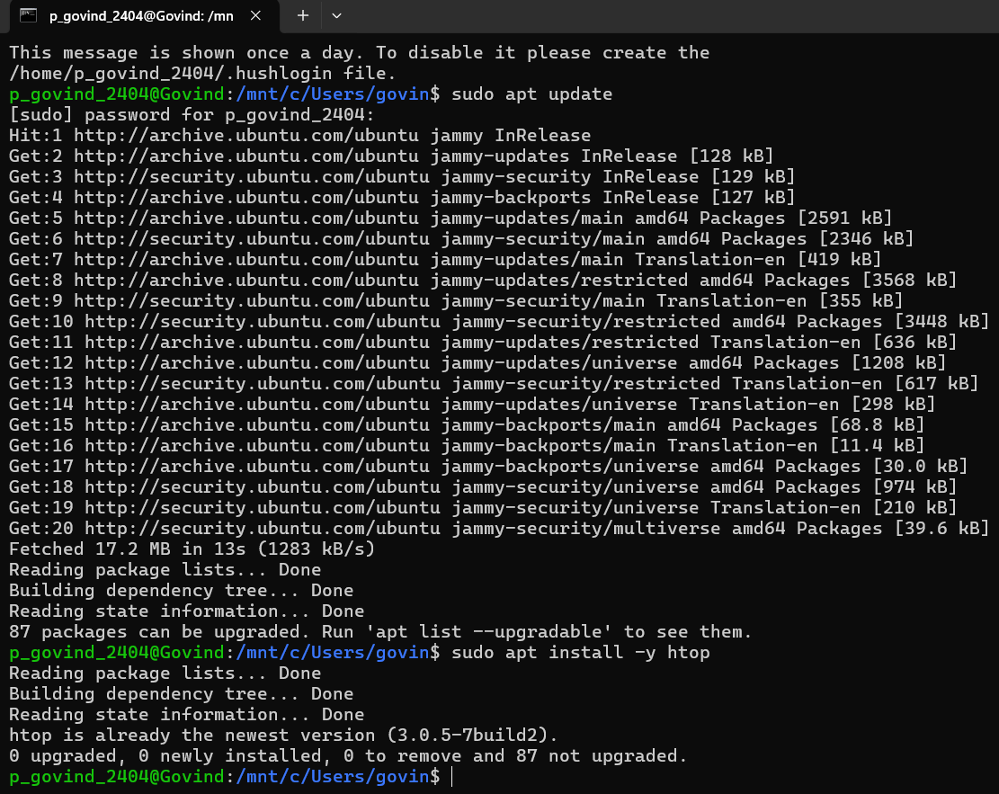

**Step 2: Verify Installation**



**Step 3: Create Monitoring Logs Directory**



**Step 4: Automate Daily Logging of System Metrics**

Create a script (*system_monitor.sh*) to collect metrics periodically:

* CPU, memory usage using htop
* Disk usage using df
* Directory space usage using du
* Top 5 resource-consuming processes

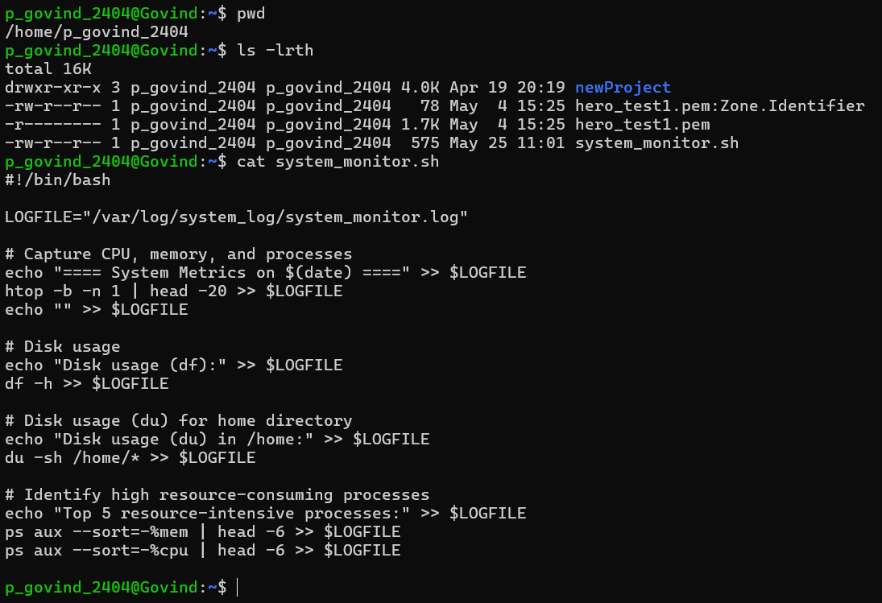

Make it executable:

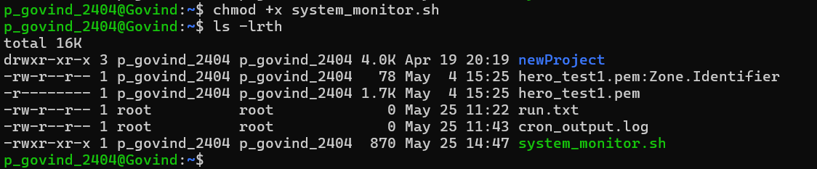

**Step 5: Test the Script**

Run the script:



Verify the output:

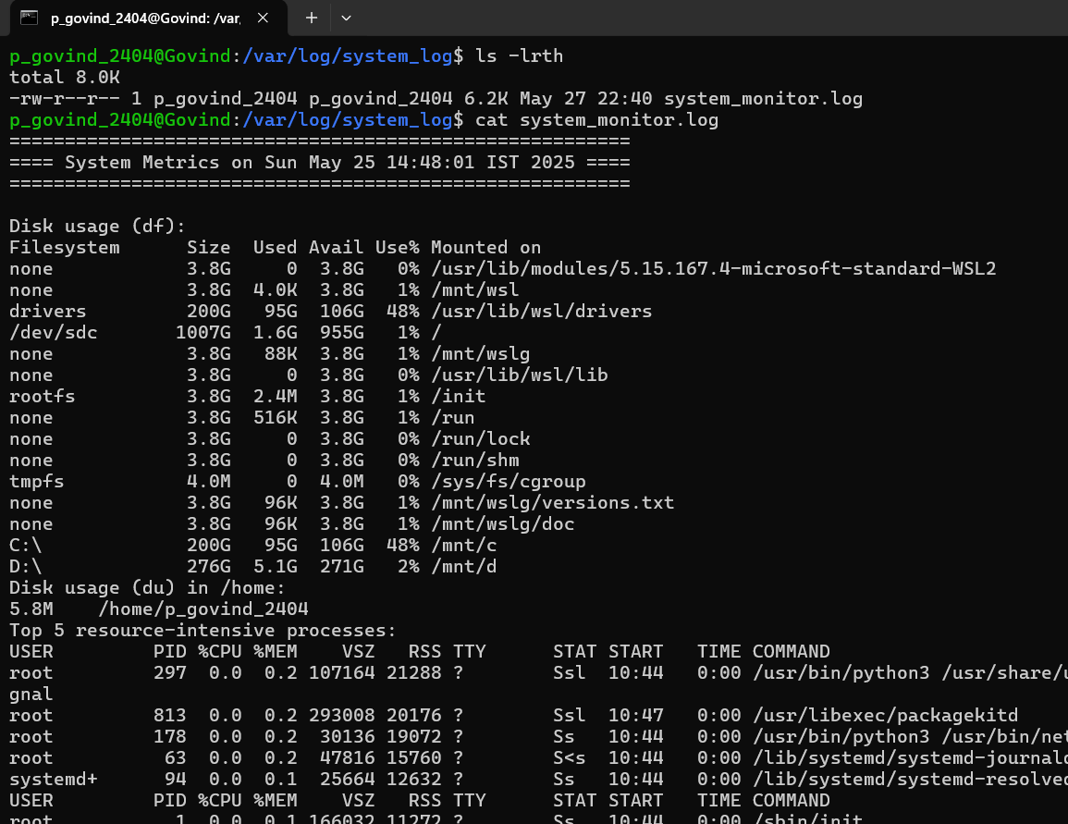

* Issue: Using **htop** command in script we are not able to capture CPU, memory usage so it is advice to stick with **top** for scripting.
* Note: If you really want to use **htop** in scripts, you'll need to run it in a pseudo-terminal, which is complicated and not recommended for cron jobs.
* Replacing htop by top for script

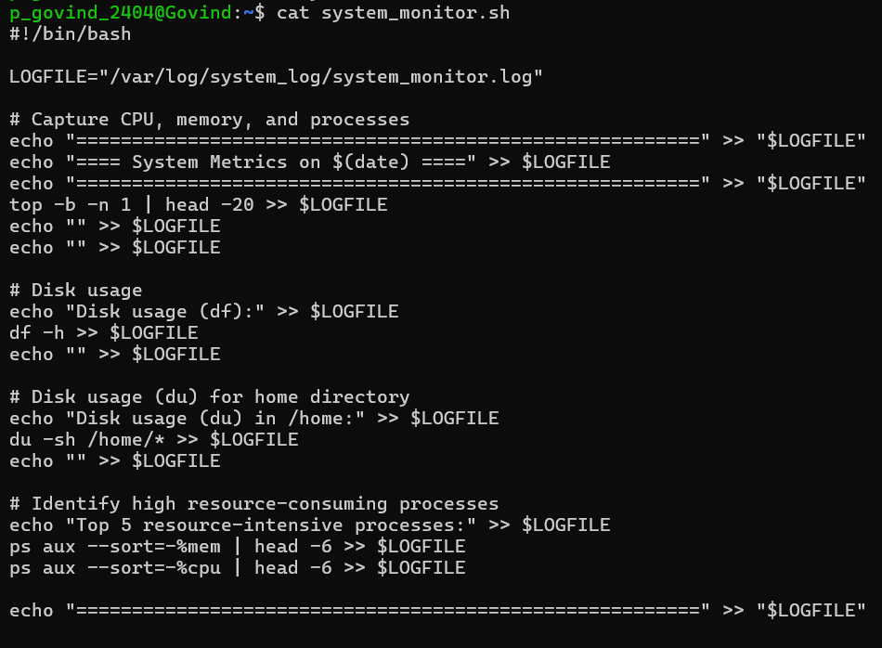

Run the script:



Verify the output:

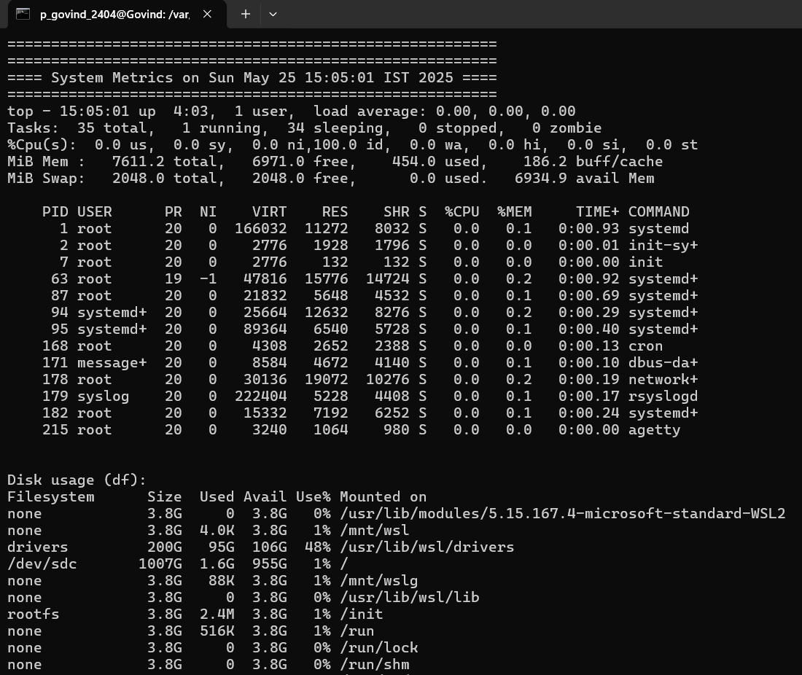

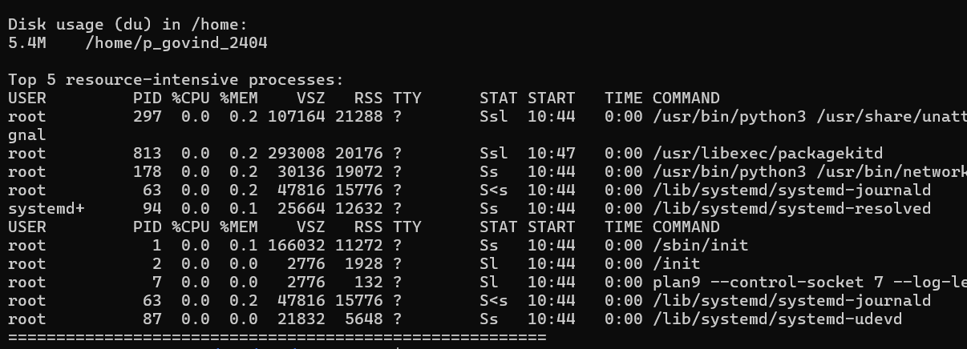

Step 6: Schedule Daily Monitoring with Cron

Edit your crontab:



Scheduled script to run every 10 min